Solids, Liquids and Gases

Complete the following table by writing 5 examples of solids, liquids and gases. One example of each has been done to get you started.
Solids | Liquids | Gases
Chocolate | Water | Nitrogen

Test the properties of solids, liquids and gases, following the teacher’s instructions, and fill in the table below.
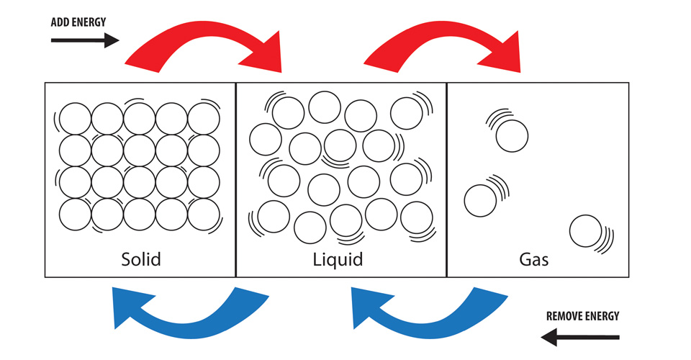
 | Solids | Liquids | Gases
Shape
Volume
Compressibility

Why does this happen?
All matter is made up of particles. In solids, liquids and gases, the particles behave differently.

Solids
In a solid, the particles are locked into place. Even though they are locked in place, they are still vibrating. If you add heat, they vibrate more because they have more energy.

Liquids
If you heat the solid, the particles will vibrate so much they can’t stay in their place any more. They start moving around. The solid has then melted into a liquid. If you add more heat, they want to move around even more because they have even more energy.

Gases
The particles in a gas are free to move around and are not held by any other particles. Gases have no definite shape.

